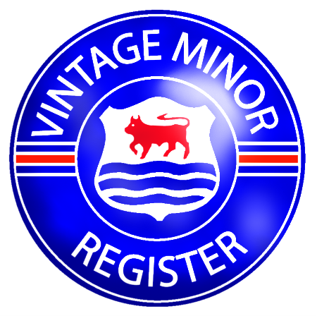

The Vintage Minor Register

Serving the Pre-War Morris Minor and M Type MG

13416 Kellogg Lake Road  Sultan  WA98294, USA | (+01) 425-602-1402  vintageminor@gmail.com  www.vintageminor.co.uk

Application for Membership

Welcome to the Vintage Minor Register, catering for all pre-war Morris Minors and M Type MG’s. Members receive four quarterly VMR Magazines and monthly e-mailed Newsletters and access to the Members’ Area of the Register’s website. The annual Register subscription is £20 (Australia $Au45, New Zealand $NZ50, USA $US40). Members joining part way through the year will receive all back issues for that year. English members, please send cheques made payable to the Vintage Minor Register to the above address. US members, please send cash or checks made payable to Ian Grace to the above address. Australian and New Zealander members, please send cheques made payable to Alex Dempster in your respective currency to Alex Dempster, 56 Pacific Street, Maori Hill, Dunedin, New Zealand. You do not have to own a Morris Minor or M Type MG to join the Register – enthusiasm is all that it required!

Your Details

Name

Address

Telephone No.

e-mail address

Your details will be kept on computer file for the maintenance of membership and chassis register records, and the production of mailing lists for Register newsletters and other Register publications. These registers and membership lists will be available to all Register members. If you do not wish your details to be published in the Vintage Minor Register or any related register publications, please advise.

Your Vehicle’s Details

Registration No. Date of first registration

Chassis No. Engine No.

Body No. Body Type

If you have a moment, please use the reverse of this form to provide a few notes about your car – history, previous owners, rebuilds, modifications, condition, etc. Can you spare a photograph of your car? If so please send one in with this application for the Register archive. Your support for the Vintage Minor Register is greatly appreciated.

Membership Referral Scheme

If an existing member has introduced you to the Register, that member is eligible for a £10 (or equivalent in other currencies) discount on his or her next year’s Register subscription.

Referring member’s name:

