Jack Blyth’s South Island Tour

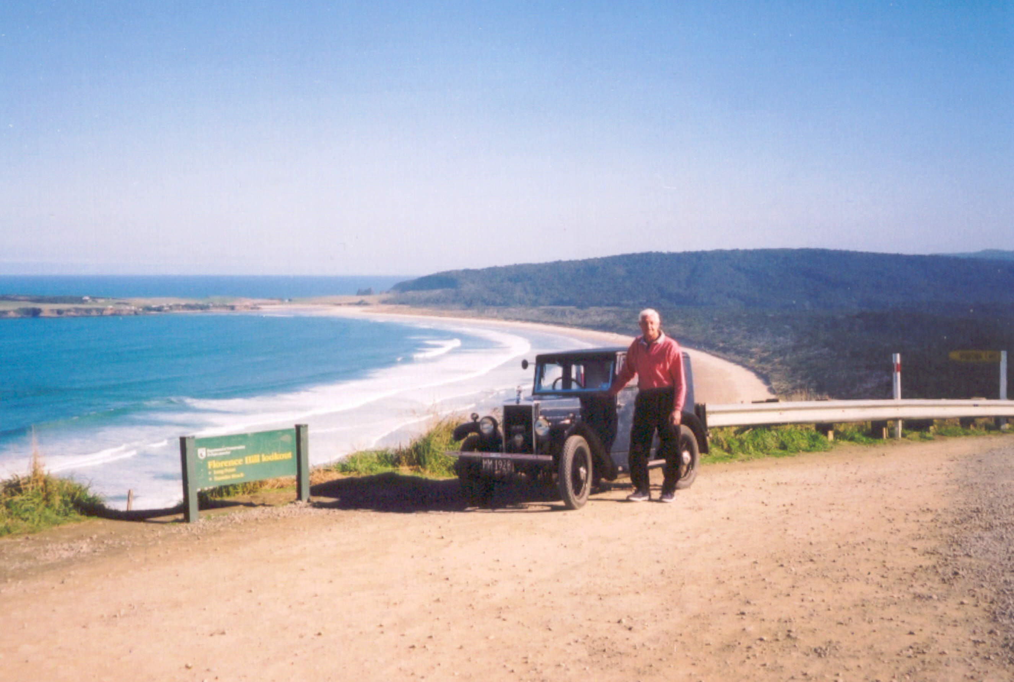

Jack and his trusty Minor pause on the spectacular southeast coastline of the South Island of New Zealand

Background
Since building my car from parts of many cars in 1971, I have always had a desire to do a long tour to prove its reliability. My first effort, a tour of the North Island with 100 other vintages, five years ago, struck a serious mechanical failure after 300k when the flywheel came loose from the crankshaft. This problem was resolved and 2003 seemed a good chance to celebrate 75 years of Morris Minors by touring the South Island, hopefully with other Minors. For many reasons no other owners could join me so on 7th April I set out alone, with a little trepidation, but a lot of confidence, north, into torrential rain and wind.

The Journey
Day 1 A 7.30 am start in foul weather got worse as the 12 volt wiper motor failed after one mile. Not having a spare, I carried on without any problem through the whale-watching centre of NZ, Kaikoura, and on to Blenheim, the major wine area of the country. Here, I stayed with friends and also fitted a new wiper motor (flown in by air overnight). The car had run well, so I slept easy.

Day 2 From Blenheim I drove through Picton, the Inter Island ferry terminal, then along the narrow winding road alongside the sounds, the Queen Charlotte Drive, through Havelock and on to Nelson, a Cathedral City home of Nelson College which I attended many years ago. The car had performed better than I had expected over two steep passes so my confidence was building. After lunch with cousins near Nelson I continued to Motueka and South along the Motueka river valley until Tapawera, a small country town where I had arranged to visit the school, so I found a bed at the local camping ground.

Day 3 When school opened I had the interesting task of talking about my car and the tour, to four junior classes, the variety and scope of the questions astounded me, then it was group photos and rides around the block. After morning tea with the staff, I continued through Murchison and the upper and lower Buller Gorges, a brief call at my hometown of Westport then down the scenic coastal road through Greymouth, a fishing port, and on to Hokitika, the greenstone carving centre of NZ. It was on this journey that a rear wheel collapsed due to several broken spokes, so the spare was fitted.
Day 4 Decided it was unwise to continue without a spare wheel so hired a rental car and took all five wheels home, over the Alps and returned with five new wheels from my partly built ’34 special. These were fitted and pressures set at 30 psi.

Day 5 Having lost a travel day, I set off before dawn, (6.30am) and managed to travel 250 miles by mid afternoon, having morning tea at Franz Josef glacier, lunch at Haast and was settled into my camp bed in Wanaka by about 4pm, tired but full of admiration for the little car. This day had included some spectacular scenery and countless winding hills where third gear was a godsend. I had earned my couple of pints of “Speights” that day.

Day 6 Having had enough of mountain passes in recent days, I chose the flat route through Cromwell, stone fruit capital of NZ, then through the Kawarau Gorge , through Queenstown and on to Te Anau, another Lake town. Here I blew the budget with a motel, bottle of wine and Chinese takeaway before an evening of rugby on Sky TV, absolute decadence.

Day 7 Weather has been brilliant since day 1, so pushed on South past lake Manapouri (site of our deep underground hydro power station ) and through Riverton, and the southern City of Invercargill to enjoy the coastal road round the “Catlins” which included the only unsealed road of the tour, 20 miles of well graded road and 20 miles of corrugations and potholes. This made me marvel at the courage and fortitude of drivers in Morris Minors 75 years ago. Stayed at a country pub, more “Speights, the brew of Southern Men”, and pool with the locals.

Day 8 Heavy fog for first 40 miles today coupled with steep narrow roads and truck and trailer units desperate to get somewhere was a frightening experience, but when the fog cleared the car and I were still in one piece and motoring well on State Highway 1 north towards home. Passed through Dunedin, the Scottish capital and on to Timaru to another comfy motel where I watched Tiger Woods crash out of the golf at Augusta.

Day 9 Only 100 miles to complete the circuit and on the long flat Canterbury Plains the car seemed to get a second wind and for the last two hours we managed 42 miles in each hour. I think it was giving me the message that it might be small and it might be old and a little underpowered but this trip was just all in a days work for an English thoroughbred. Maybe I will tour the North Island for the 80th anniversary?

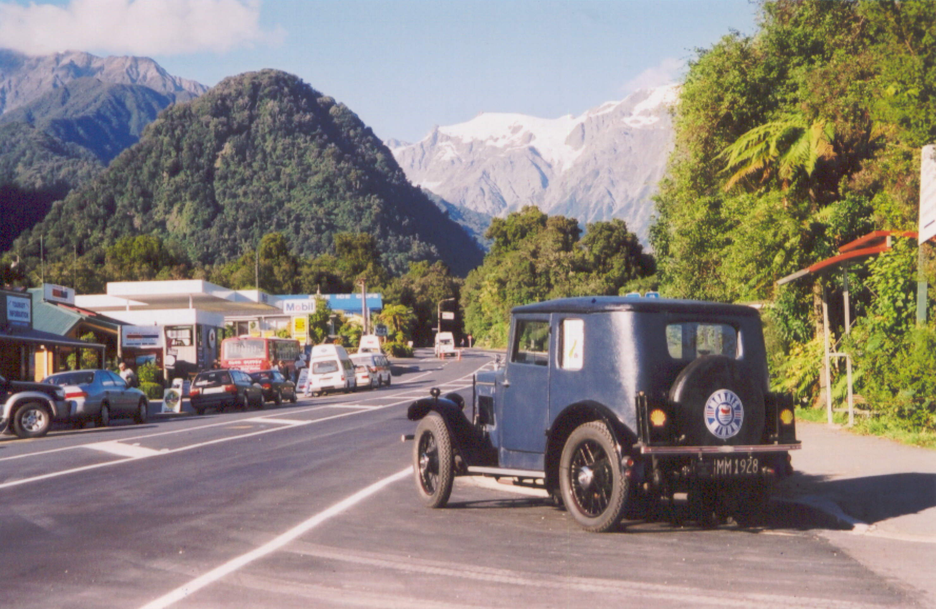

Franz Josef village with alpine scenery

