AMA 630 1933 Trike TW-33-10 Peter Cook
I have written previously about the three 1933 trikes purchased by my father direct from the BSA factory for his brother John (Jack) Cook, Fred Harris (who was a motor cycling friend of my father) and my father (AMA 893). The photograph, taken I assume in 1933, shows the three trikes outside my father’s garage (J A Cook & Sons Ltd, Victoria Garage) in Newton, just to the east of Hyde, in what was then Cheshire.
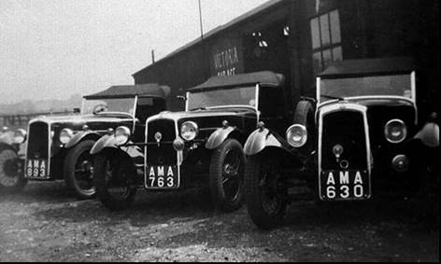
What is unique about my Uncle Jack’s car, AMA 630, is the surviving documentation, which spans the period from my father’s first enquiry to BSA’s, the BSA invoice, the insurance cover note and various photographs including those taken during a trip he made to Europe with my Aunt in 1936.
So as I have the time during the lock down I thought I might expand on the story, show some of the documentation and a few of the additional photographs that turned up recently.
So first let me give you a bit about my Uncle. Born in 1903 he was apprenticed to an engineering company on the out skirts of Manchester and was in the 1930’s working for a printing machine company. This involved him travelling around the UK and Europe erecting and commissioning large printing presses. He had two quite substantial tool boxes, which I understand went with him on his site visits and I still have one plus all his tools. He moved south at some time in the 1930’s and from the surviving correspondence appeared to be living in St Albans at the time of the purchase. However the registration records and correspondence relating to the trike’s insurance also give his address as the one in Newton where my grandparents lived at the time.
So when does the story AMA630 begin. The first letter I have is a carbon copy of one written by my father to BSA’s on the 5th June 1933. This refers to an enquiry from a customer for a four cylinder trike and he asks whether the trike can be supplied with a fold down screen. At this time my father was probably driving an early V twin Trike. He was selling cars but was not involved in purchasing new Trikes direct from the BSA factory. He asks in the letter about the possibility of having an arrangement where he could make purchases direct from the factory rather than through an agent. BSA’s responded on the 8th June 1933 and stated that it was not possible to fit a fold down screen as the Four-Cylinder three-wheeler came within a “pound or so” of the maximum weight for licensing purposes. They also state that regarding the commercial terms they were in discussion with their local representative.
The next letter is dated the 12th June1933 in which BSA state they are pleased to quote direct terms for three wheeler “production”. BSA state that if my father agrees to keep in stock one three wheeler throughout the selling season for exhibition and demonstration purposes they would consider quoting against their full stocklist terms. A copy of the trade price list for 1933 was provided and survives. The TW-33-10 Four Cylinder Special Sports is quoted at a retail price of £125, a trade stock list price of £103 2s 6d and a non-stock list price of £106 5s. The trade list also indicates that there was a settlement discount of 2½% for cash.
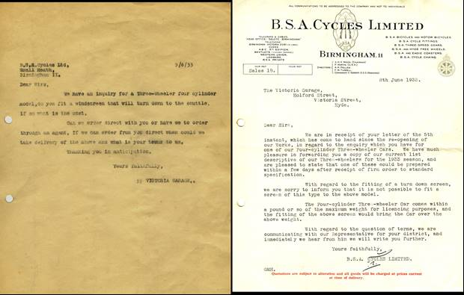
The next letter is a carbon copy of one from my father to my Uncle dated the 13th June 1933 informing him of the prices and asking for confirmation of his order. We then have a letter dated the 15th June 1933 from my father to my Uncle acknowledging his order. On the 16th June 1933 we have the carbon of the order my father placed with BSA for the TW-33-10 four cylinder special sports. He requested details of the engine and chassis number in order that arrangements could be made to secure the registration number. The letter also indicates that the customer (my Uncle) had recently moved south. We then have a letter from BSA’s dated the 16th June 1933 acknowledging the order and quoting the Engine Number (1233) and the Chassis Number 6078. The letter as a sticker attached detailing the times when three wheelers, cars and vans can be collected from the factory.
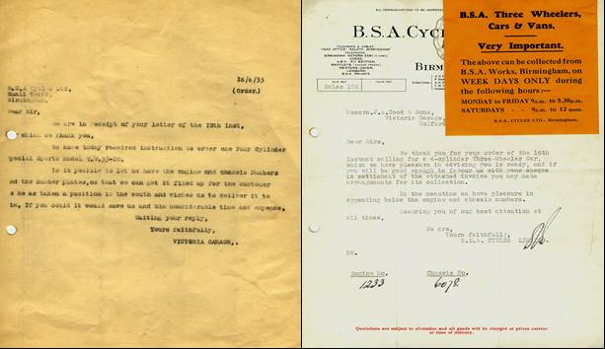
We then have a series of letters that relate to the payment with a cheque for £104 2s 1d being sent by my father to BSA together with the completed sales agreement. On the 22nd June 1933 my father writes a letter, which authorises the bearer to be given the Three Wheeler. BSA acknowledges on the 22nd June 1933 receipt of the cheque and confirm that collection will be made on the 23rd June 1933, which was a Friday
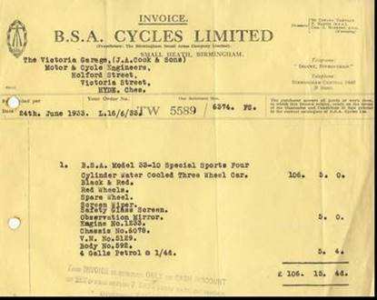
The invoice dated the 24th June confirms the colour as Black and Red with Red wheels. It was supplied with a spare wheel, screen wiper, safety glass and observation mirror. The observation mirror appears expensive at cost of 5s. The trike was also supplied with 4 gallons of petrol at the princely cost of 1s 4d per gallon.
The invoice quotes the engine and chassis number and also provide a V.N. No (5129) and a Body No (592). I assume the V.N.No is the BSA vehicle number.
While all this was going on my father was arranging insurance cover for the car. The insurance was placed with Fred Fishwick & Co Ltd and it is possible my father was an agent for the company as he seemed to be involved with the provision of insurance cover well into the 1960’s. When we cleared my Uncle’s house in East Sheen, following is death in 1983, we found at the bottom of a one foot high pile of paper the Trike insurance cover note dated 10am on the 17th June 1933. The cover note is counter stamped Cheshire CC Licenses dated the 19th June 1933. The cover note would allow the trike to be taxed, a registration number obtained and the number plates produced.
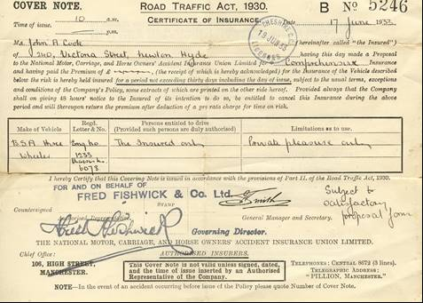
So there we have it the first BSA Trike purchased by my father direct from the factory. From the initial enquiry on the 5th June to collection from the factory on the 23rd June that is a total of 18 days which seems very quick when you consider that much of the correspondence was undertaken by letter.
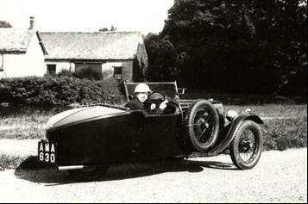
So what happens next. Well my uncle got married to my aunty Cis in the 1930’s and we have other photographs, like the one above, of Cis driving the car. We had assumed this photograph was taken in the UK as during their travel around Europe it was fitted with a luggage rack. However the photographs that recently turned up were taken in Scotland and these show the trike fitted with a luggage rack.
We knew Uncle had been to Europe as among his photographs were ones taken at some of the German Nazi sites. Again when we were clearing the house we came across is RAC International Driving permit dated August 1936.
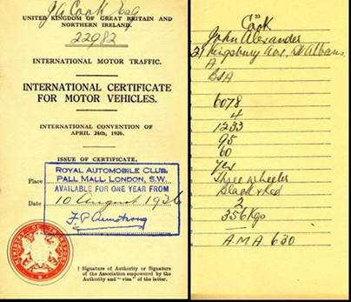
The trip involved a channel crossing with the car and the photograph below shows the trike being loaded on to a ship.
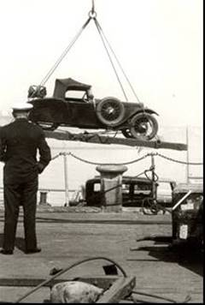
The trike is seen to be fitted with a luggage rack and carrying a reasonable sized case. You can also make out that the trike was fitted with dummy knock on hub caps. However, that may not have been the only luggage carried as the photograph below of my Aunt shows another small case in the car. This is a great period shot, showing the well-fitting hood with the small rear window.
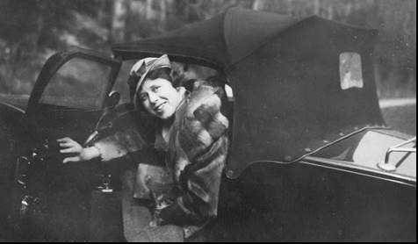
I think they were very adventurous but that is typical of my Uncle and a trip in to Germany in BSA trike would seem to be nothing out of the ordinary even if it was in the 1930’s.
The photograph below is from one of the negatives I found recently and show my Aunt with a friend driving the trike. We think this was taken in Scotland as it is with a group taken at Gretna.
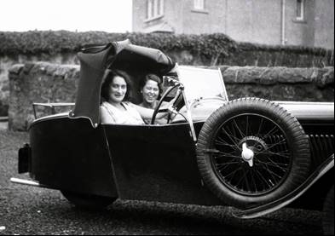
The photograph below show my Uncle erecting or taking down the hood at Great Green on another long trip in the trike.
So why does all this material survive. The photographs are easy. I inherited all the family photographs including my Uncles, which I acquired when we cleared his house.
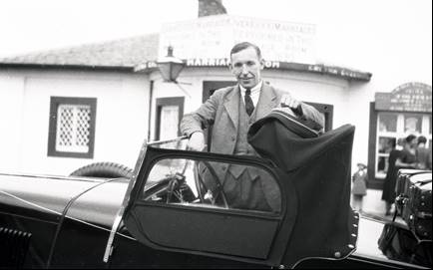
The surviving BSA correspondence is perhaps more a piece of luck. My father and one of his other brothers, my Uncle Tom a coal merchant both worked from Victoria garage, which was acquired by the family sometime in the late 1920’s. They continued working at the garage until my father’s retirement in the early 1970’s.
Being a bit of a ferreter I was poking around the office in the garage in the late 1960’s and found a series of old ring binder full of correspondence relating to the garage from the 1930 and I eventually inherited these. Why my father kept them I will never know but they are a lucky survivor from the 1930’s. May be that is where I got my hoarding habit from.
My uncles paper work is more difficult to explain. He did not move to East Sheen until after 1936. Why he kept the cover note on a table under a pile of other material heaven knows. I do know that clearing is house was like and archaeological dig. You could not throw anything away before you first looked to see what was there and that included under draw linings where we found family letters.
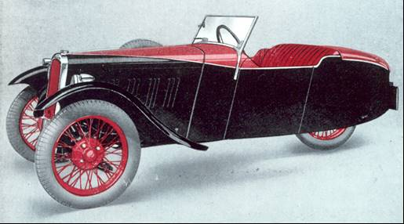
The final image is of a TW-33-10 trike, taken from the 1933 brochure, showing the same colour scheme for the trike owned by my Uncle and the two other. Does AMA 630 or any of the other two survive? I doubt they do but it would have been great to have seen one of the three.
My Uncle probably sold his trike in 1937 or 38 when he moved on to four wheel cars. My father’s trike, AMA 893, was converted into a four wheeler, which I have also written about, and he used this throughout the Second World War until he joined the RAF.

